**C Programming and Data Structures**

**Computer Science and Technology-B**

**Week 15**

a) Write a C program to copy the file contents from one file to another file (pass file names as Command line arguments).

**Program:**

#include<stdio.h>

#include<stdlib.h>

void main()

{

FILE *fp,*fp1;

char c;

fp=fopen("C:/Users/Administrator/Desktop/c progra/file2.txt","r");

fp1=fopen("C:/Users/Administrator/Desktop/c progra/file3.txt","w");

c=fgetc(fp);

while(c!=EOF)

{

fputc(c,fp1);

c=fgetc(fp);

}

fclose(fp);

fclose(fp1);

}

**Output:**

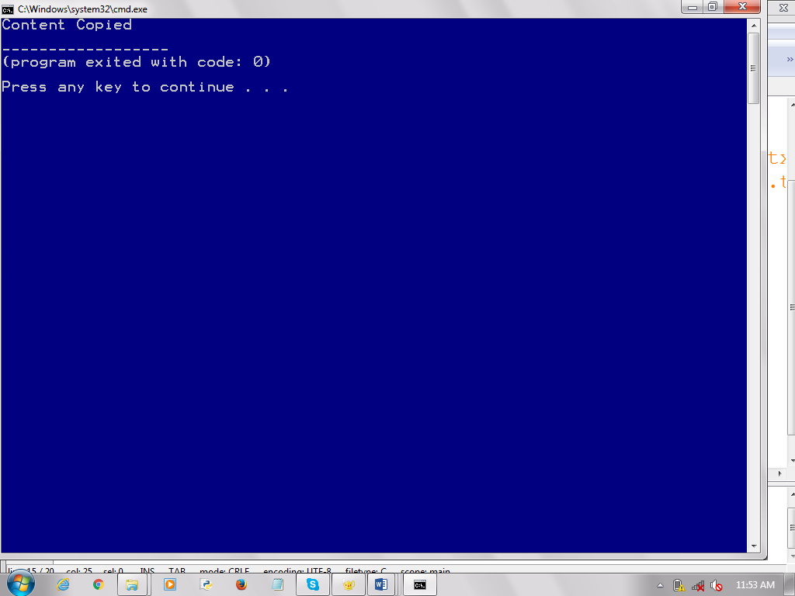

b) Write a C program to count no of lines, words and characters in a file.

**Program:**

#include<stdio.h>

#include<stdlib.h>

void main()

{

FILE *fp;

char c;

int w=1,ch=0,l=1;;

fp=fopen("C:/Users/Administrator/Desktop/c progra/file2.txt","r");

if(fp==NULL)

{

printf("File does not exist");

}

else

{

c=fgetc(fp);

while(c!=EOF)

{

printf("%c",c);

if(c==' ')

{

w++;

}

else if(c=='\n')

{

l++;

}

else

{

ch++;

}

c=fgetc(fp);

}

printf("\nTotal lines:%d",l);

printf("\nTotal words:%d",w);

printf("\nTotal Charecters:%d",ch);

}

fclose(fp);

}

**Output:**

